Appendix C – Descriptive Statistics for the IP Index

This appendix provides more information on the novel IP index developed and used in this paper. Figure C-1 shows the most recent value of the index by country. The distribution of these values is presented in Figure C-2 as a histogram. In Table C-1 we report descriptive statistics for the entirety of the dataset as well as for each year separately. Finally, Figure C-3 provides a visualization in the changes IP Index scores over time.

Figure C-1: Graphical representation of developing countries coloured according to their IP Index scores for 2011, the most recent time period collected.
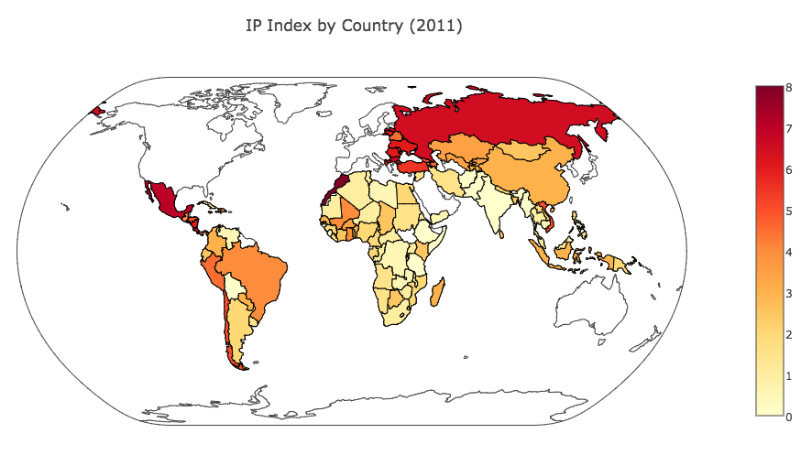

Figure C-2: A histogram representing the frequency of IP index scores of developing countries in 2011, the most recent time period for which data was collected. The mean and median of the distribution are indicated.
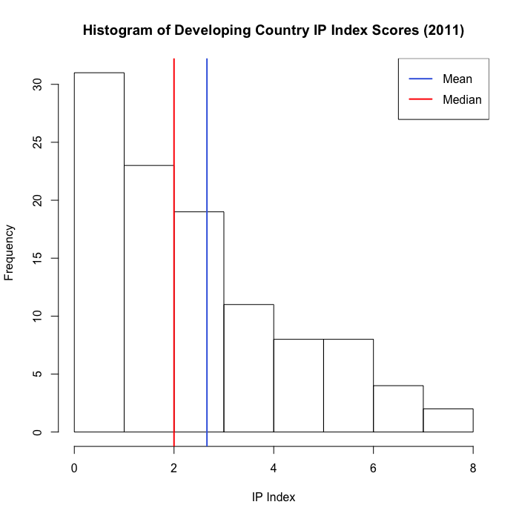

Table C-1: Descriptive statistical properties of the IP index and the number of data points across the entire data set and by year.
 | Minimum | Maximum | Mean | Median | Standard Deviation | Number
All Years | 0 | 8 | 2.028 | 1.5 | 1.649 | 1862
1995 | 0 | 4 | 1.131 | 1 | 0.891 | 107
1996 | 0 | 6 | 1.208 | 1 | 1.014 | 108
1997 | 0 | 6 | 1.271 | 1 | 0.992 | 109
1998 | 0 | 6 | 1.381 | 1.5 | 1.041 | 109
1999 | 0 | 6 | 1.445 | 1 | 1.082 | 110
2000 | 0 | 6 | 1.629 | 1.5 | 1.191 | 112
2001 | 0 | 6 | 1.714 | 1.5 | 1.275 | 112
2002 | 0 | 7 | 2.110 | 2 | 1.532 | 114
2003 | 0 | 7 | 2.246 | 2 | 1.641 | 114
2004 | 0 | 7 | 2.350 | 2 | 1.714 | 113
2005 | 0 | 7 | 2.456 | 2 | 1.777 | 113
2006 | 0 | 7 | 2.605 | 2 | 1.886 | 110
2007 | 0 | 7 | 2.551 | 2 | 1.883 | 107
2008 | 0 | 8 | 2.584 | 2 | 1.924 | 107
2009 | 0 | 8 | 2.557 | 2 | 1.885 | 105
2010 | 0 | 8 | 2.613 | 2 | 1.936 | 106
2011 | 0 | 8 | 2.660 | 2 | 2.013 | 106

Figure C-3: The values of the IP index for developing countries in a given year are plotted to demonstrate trends over time. Darker shading represents a greater number of countries with that IP Index score in that year. The red line tracks the change in mean score over time.
